Step 1: Entering basic information.

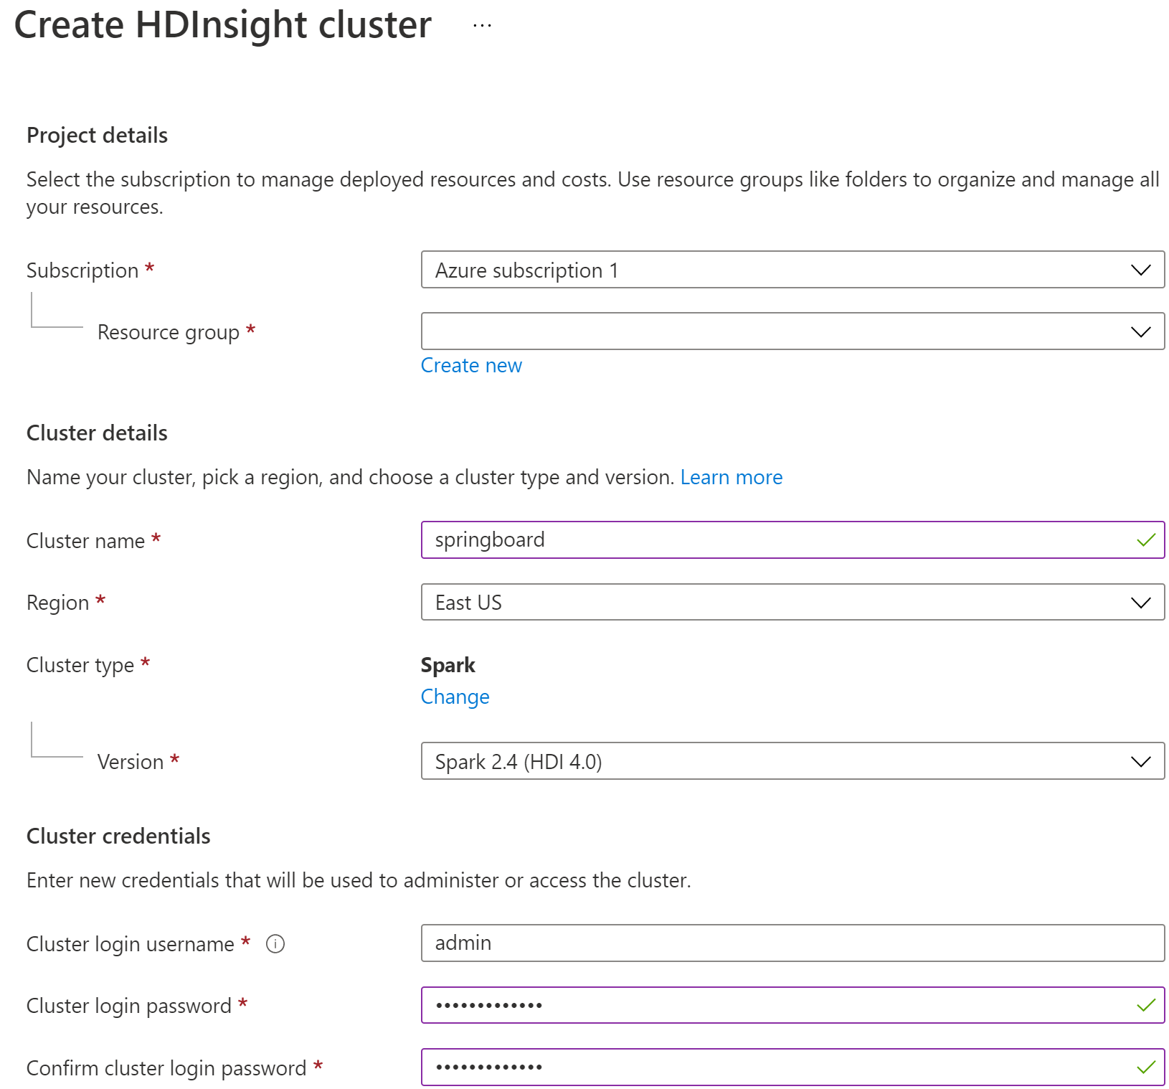

Step 2: Entering Storage Information details

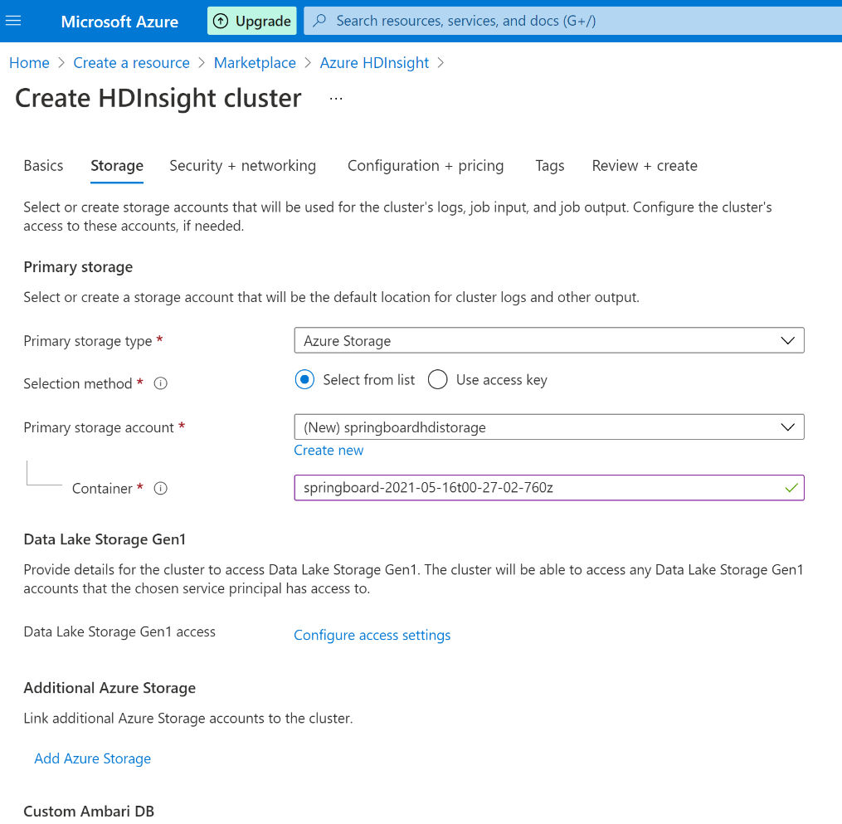

Step 3: Security and Networking Information

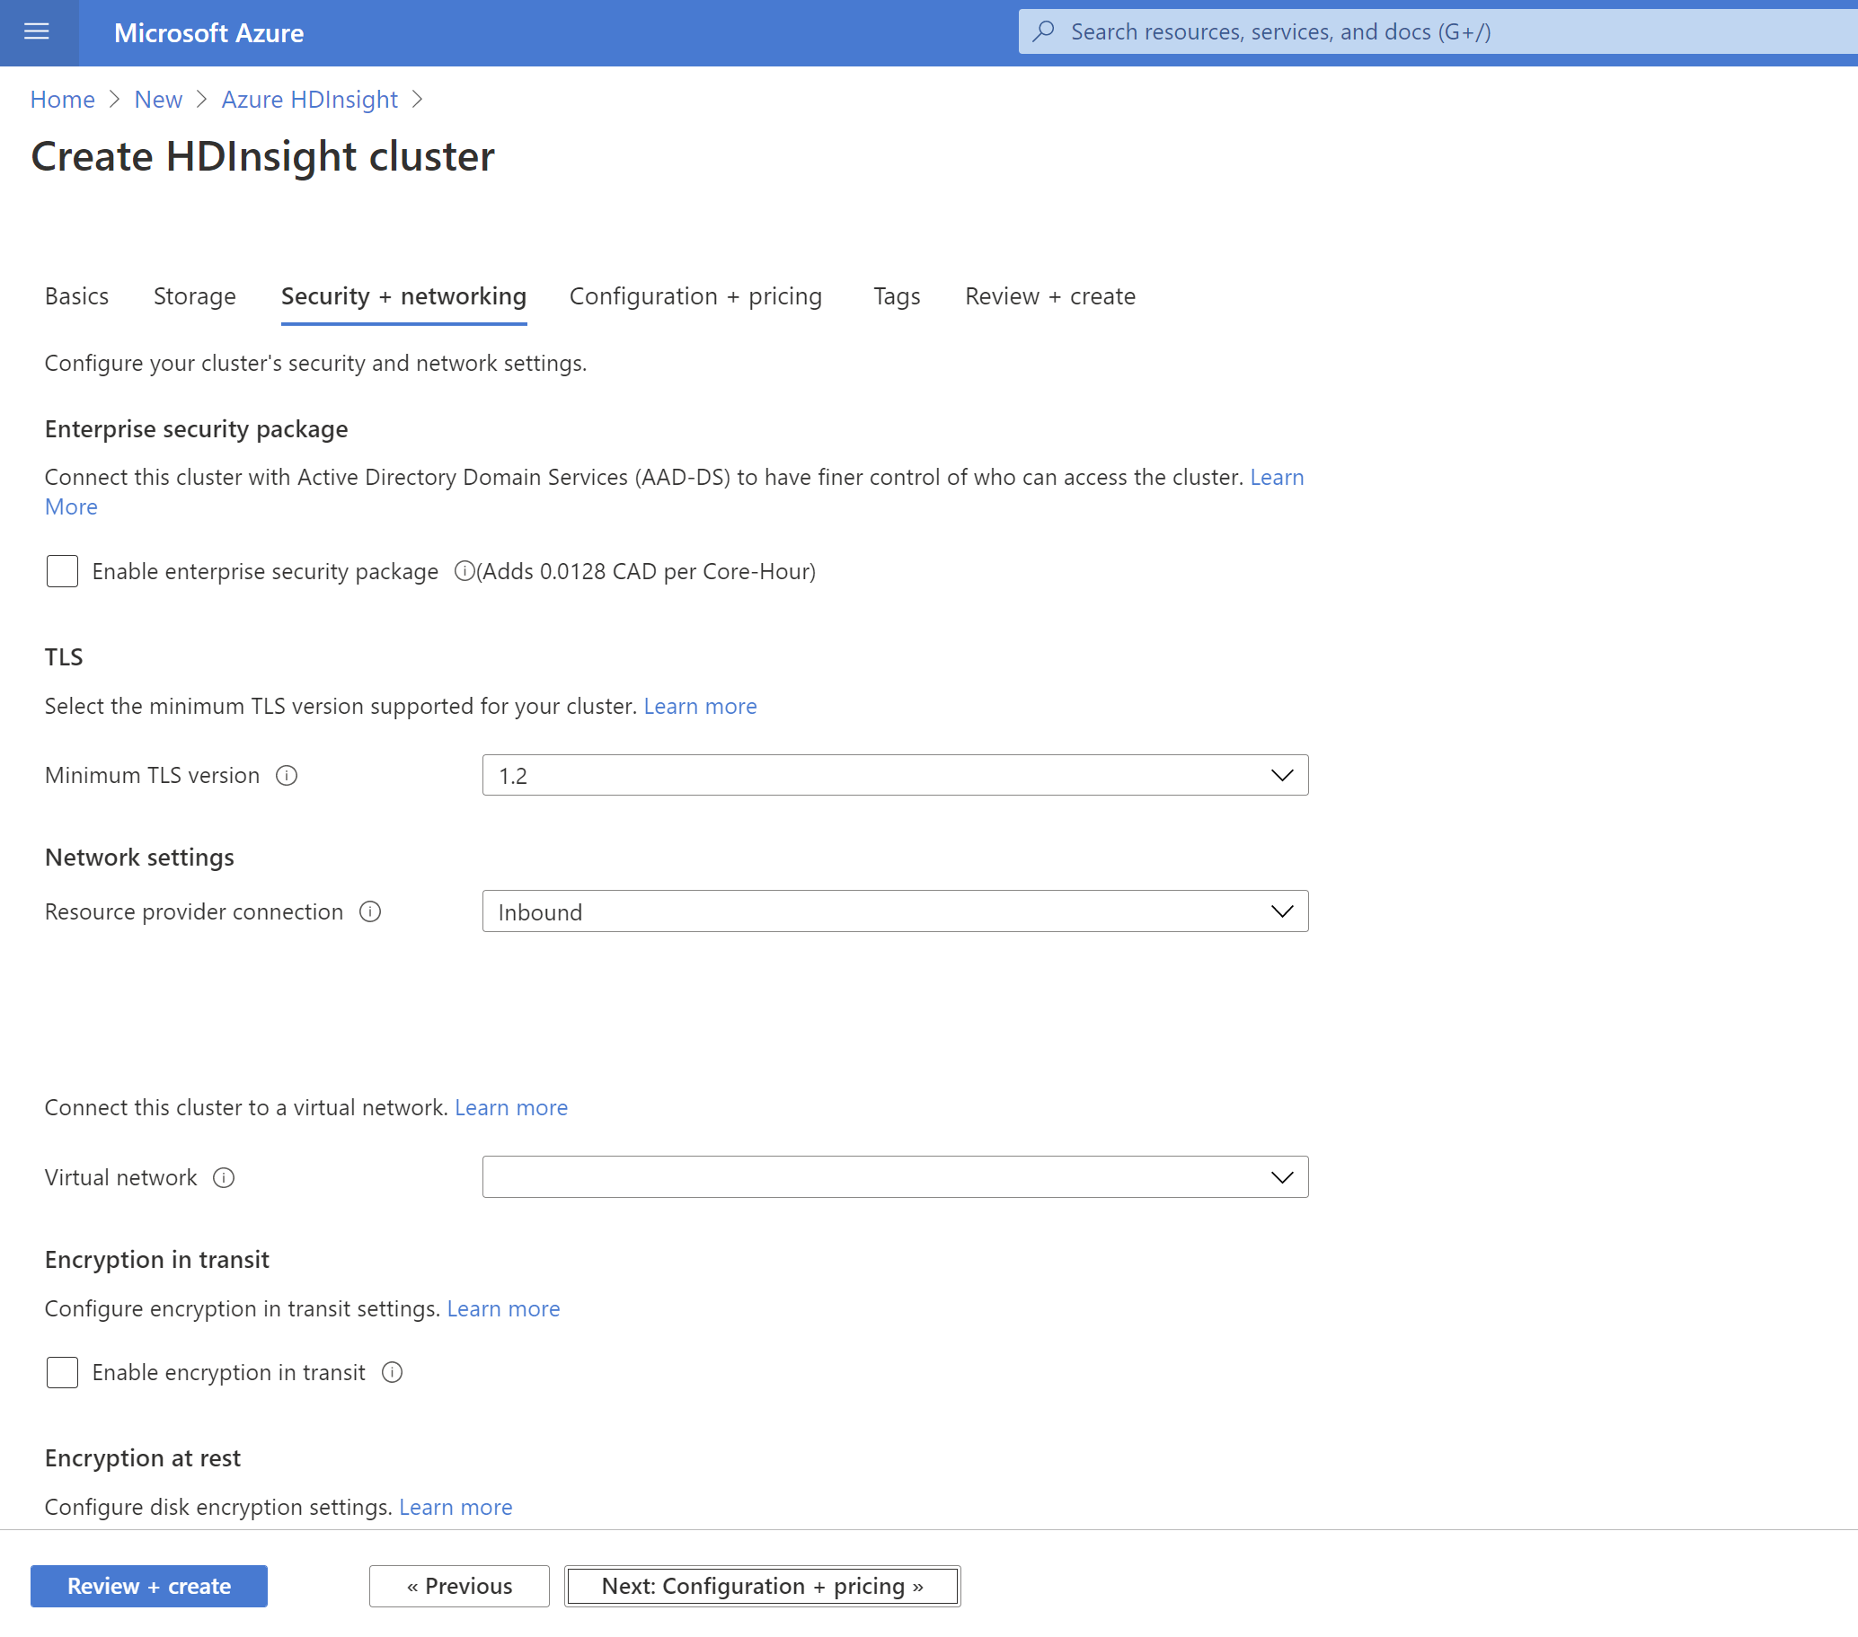

Step 4: Configuration + pricing

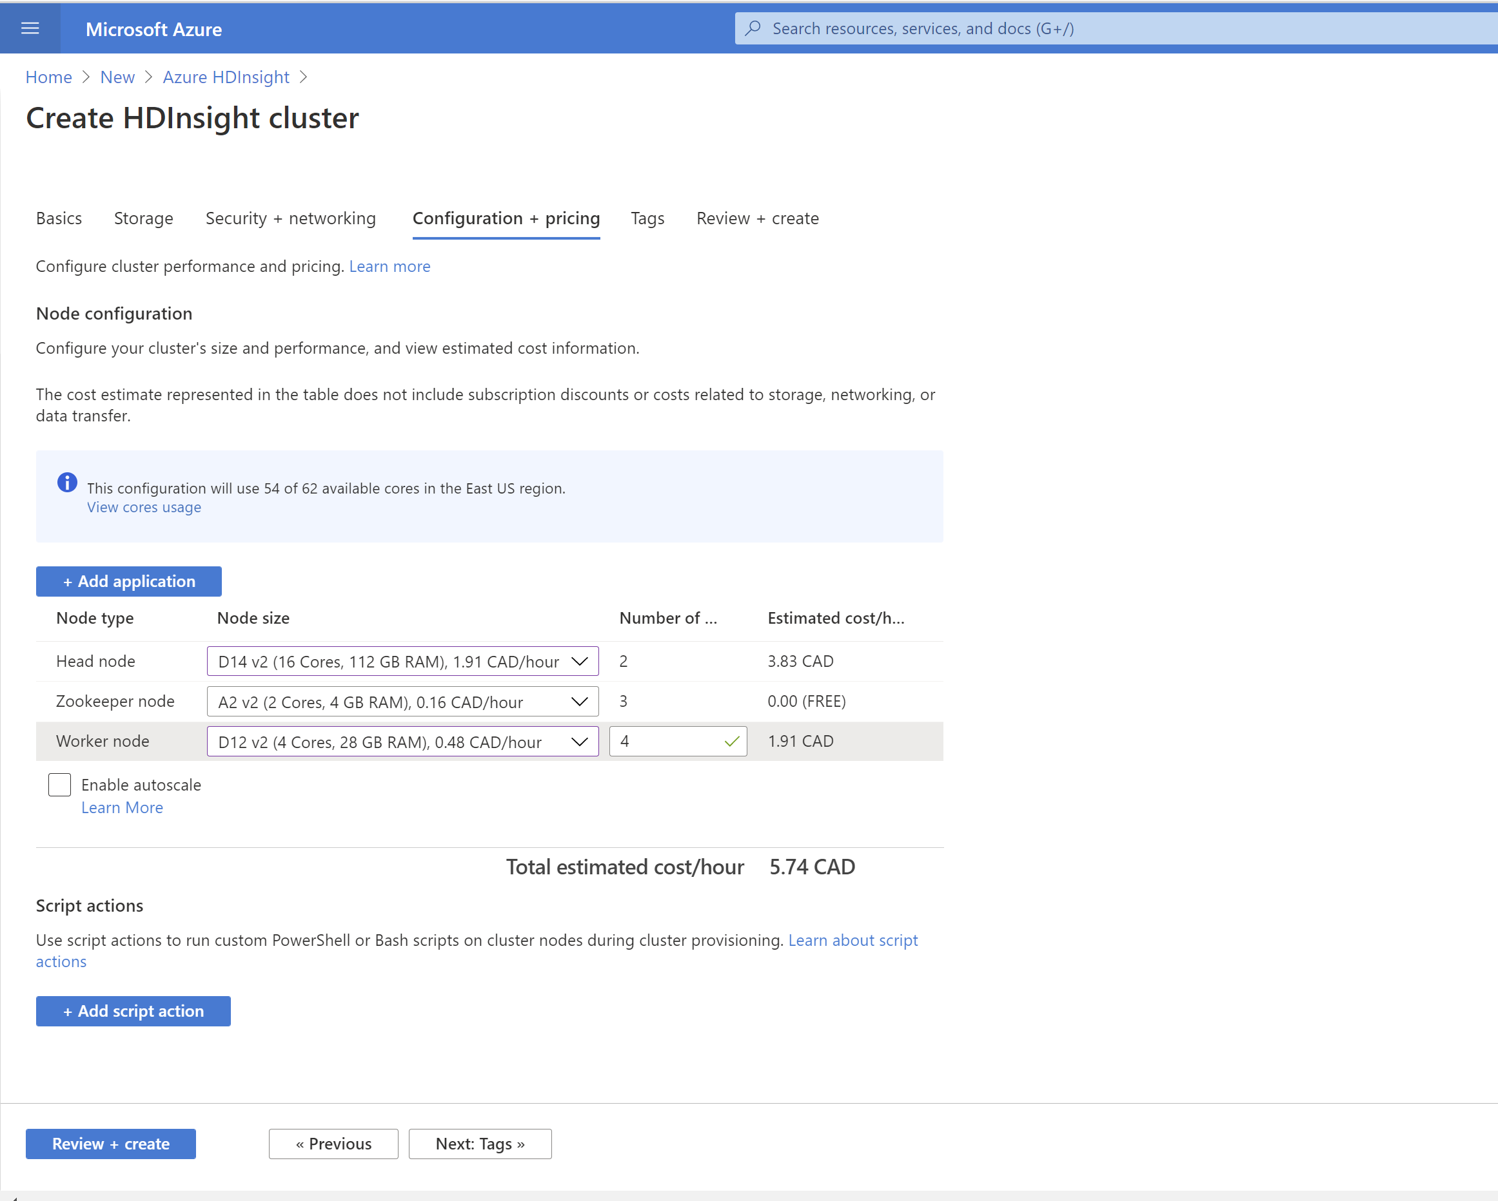

Step 5: Setting tags. Left it blank.

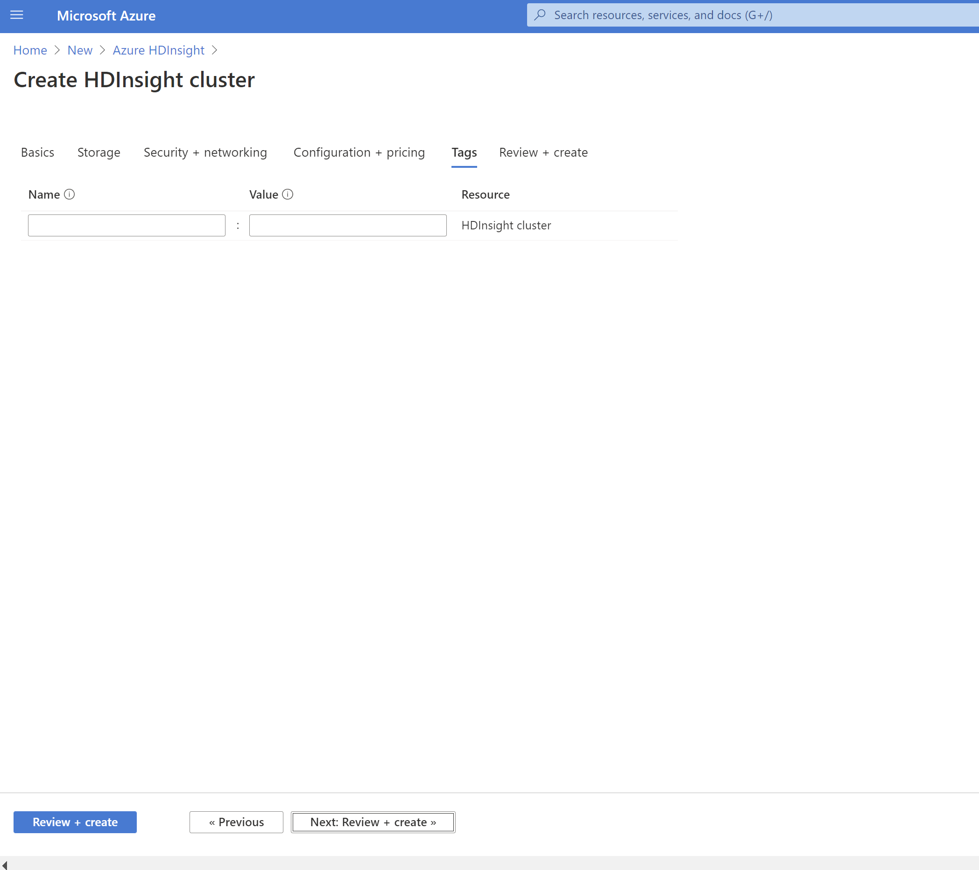

Step 6: Review + Create. Validation succeeded.

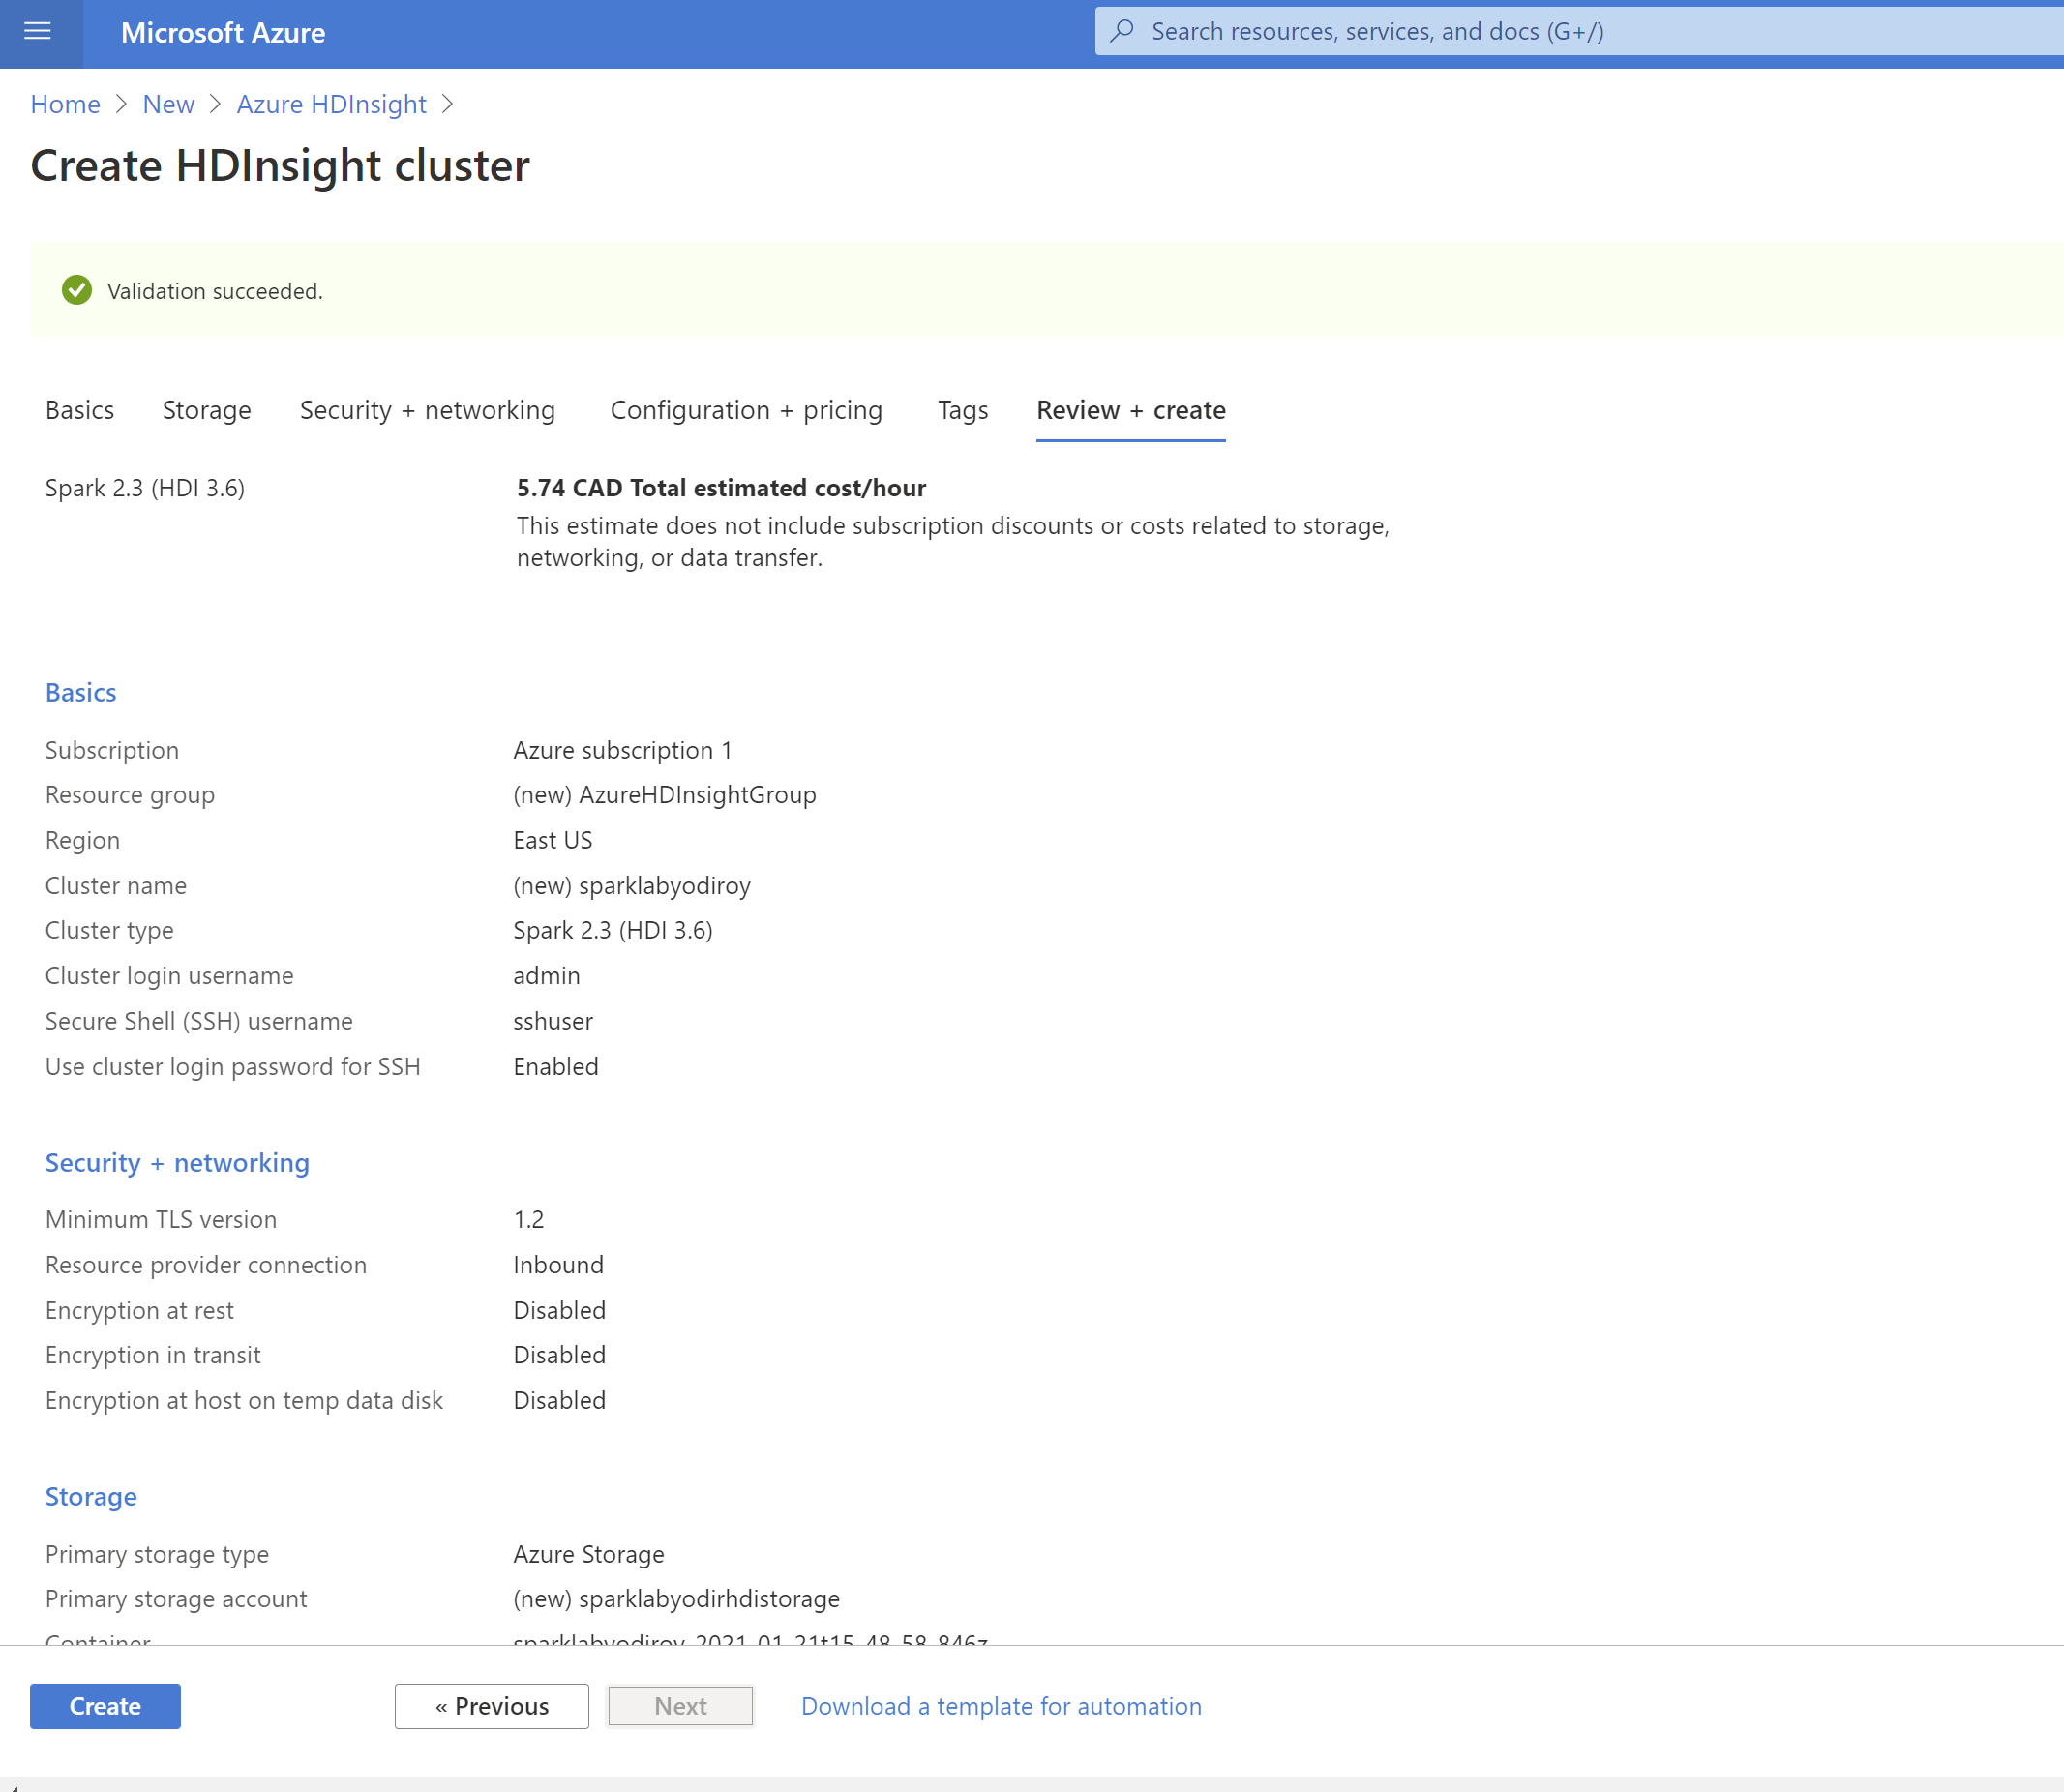

Deployment in progress

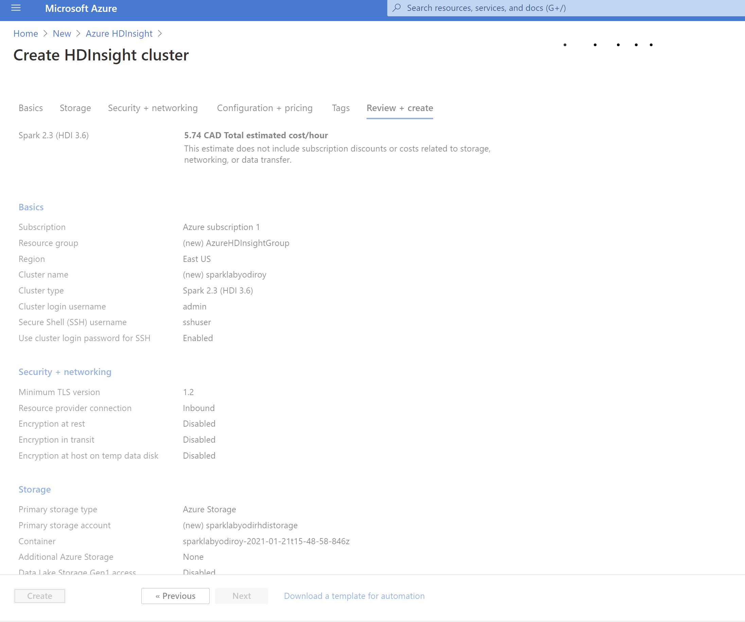

Deployment is completed

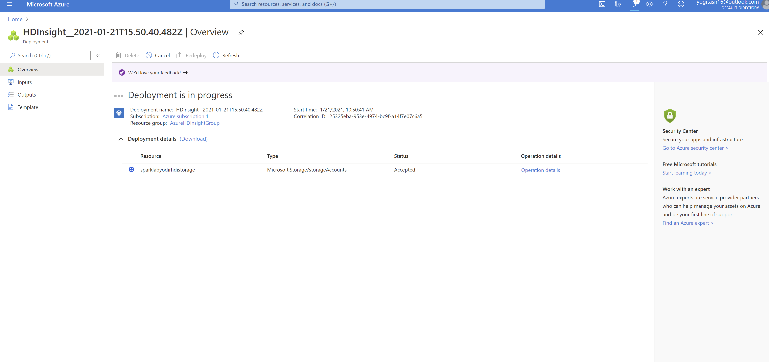

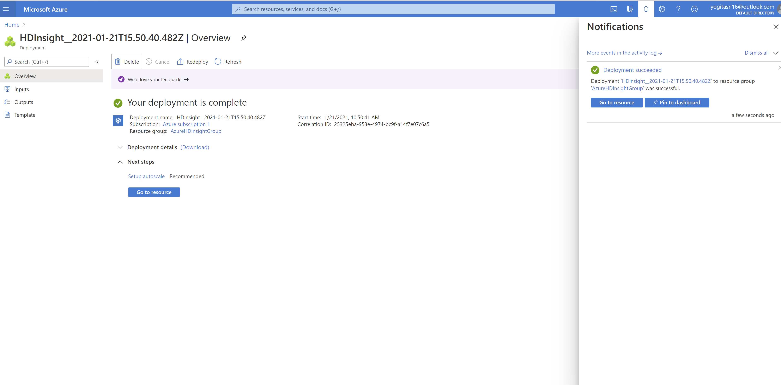

Uploaded Notebook and Walmart.csv file in Microsoft Azure Storage Explorer

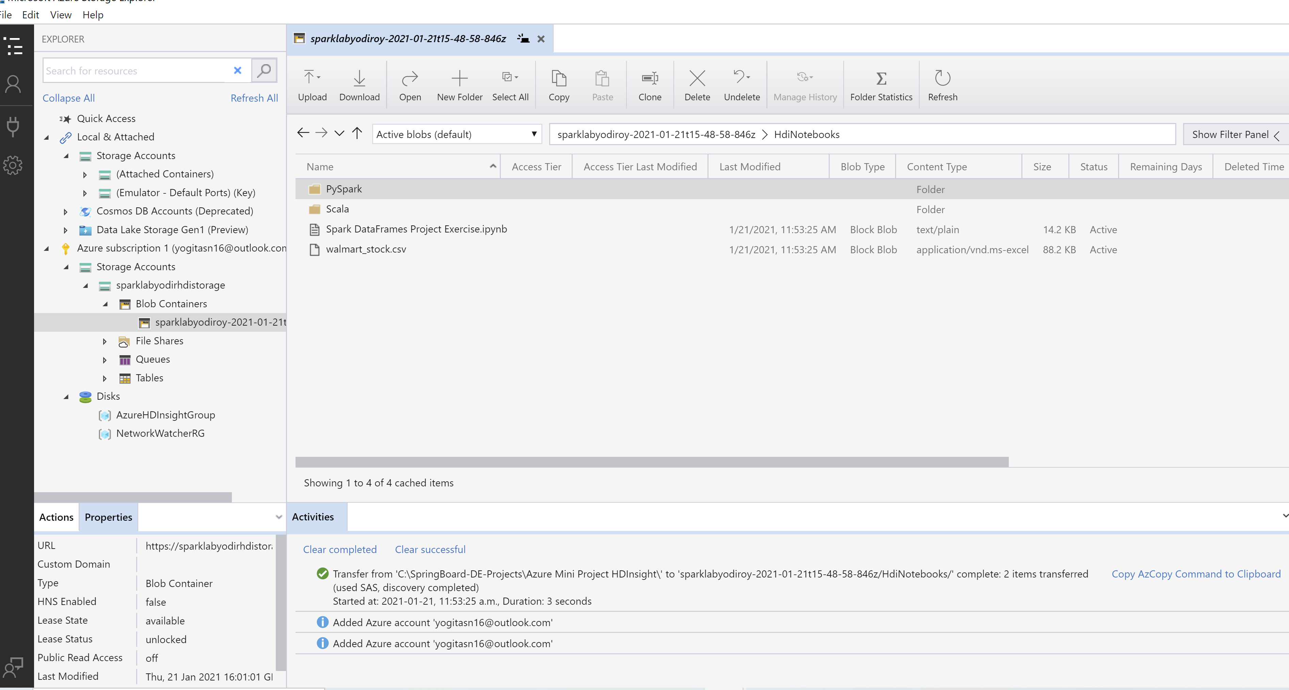Navigated to Resource group

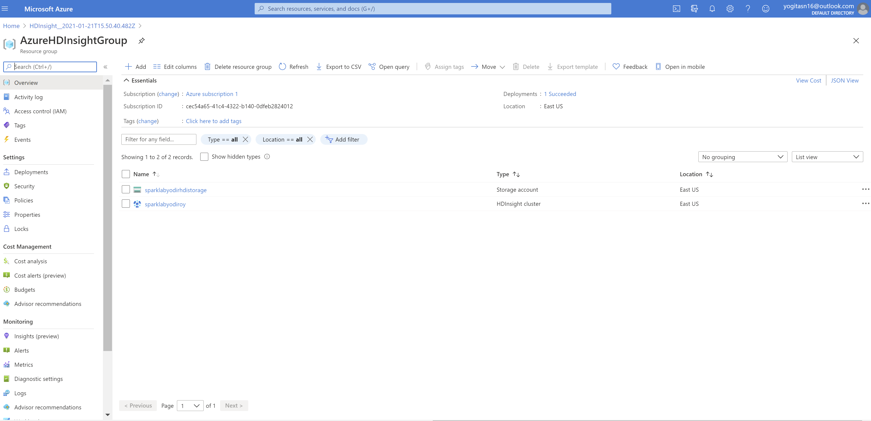

Clicked on the created HDInsight cluster ‘sparklabyodiroy’

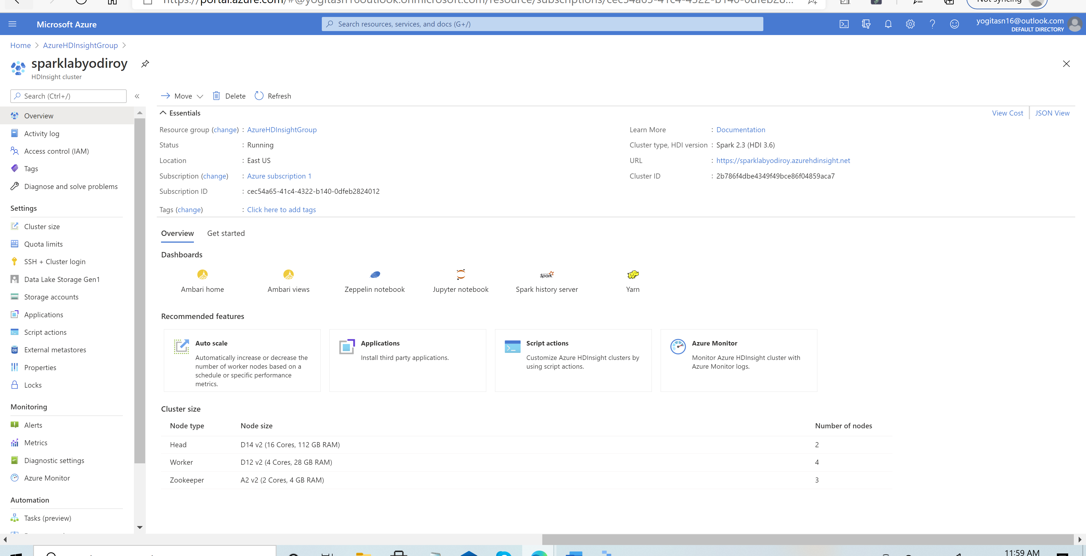

Launched Jupyter notebook by entering valid credentials below.

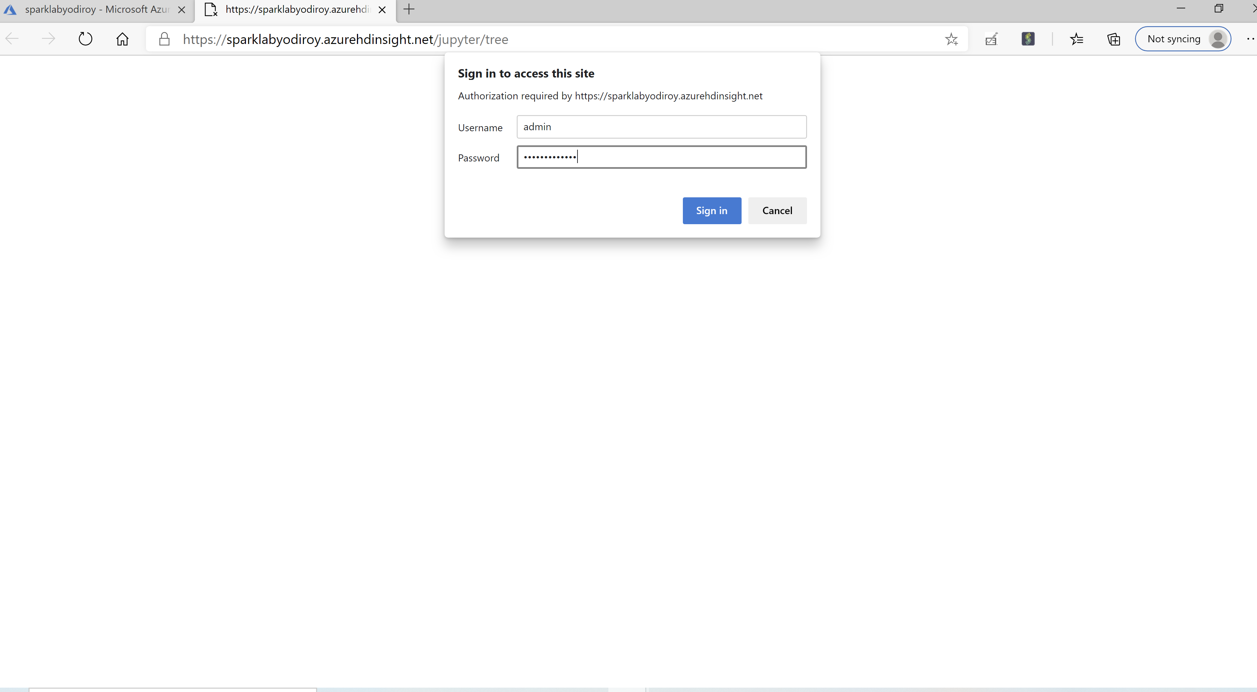

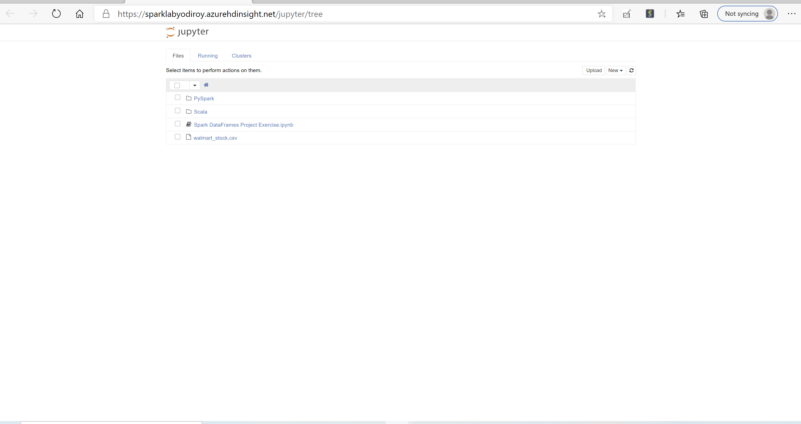

Worked on the Pyspark exercises in the notebook.

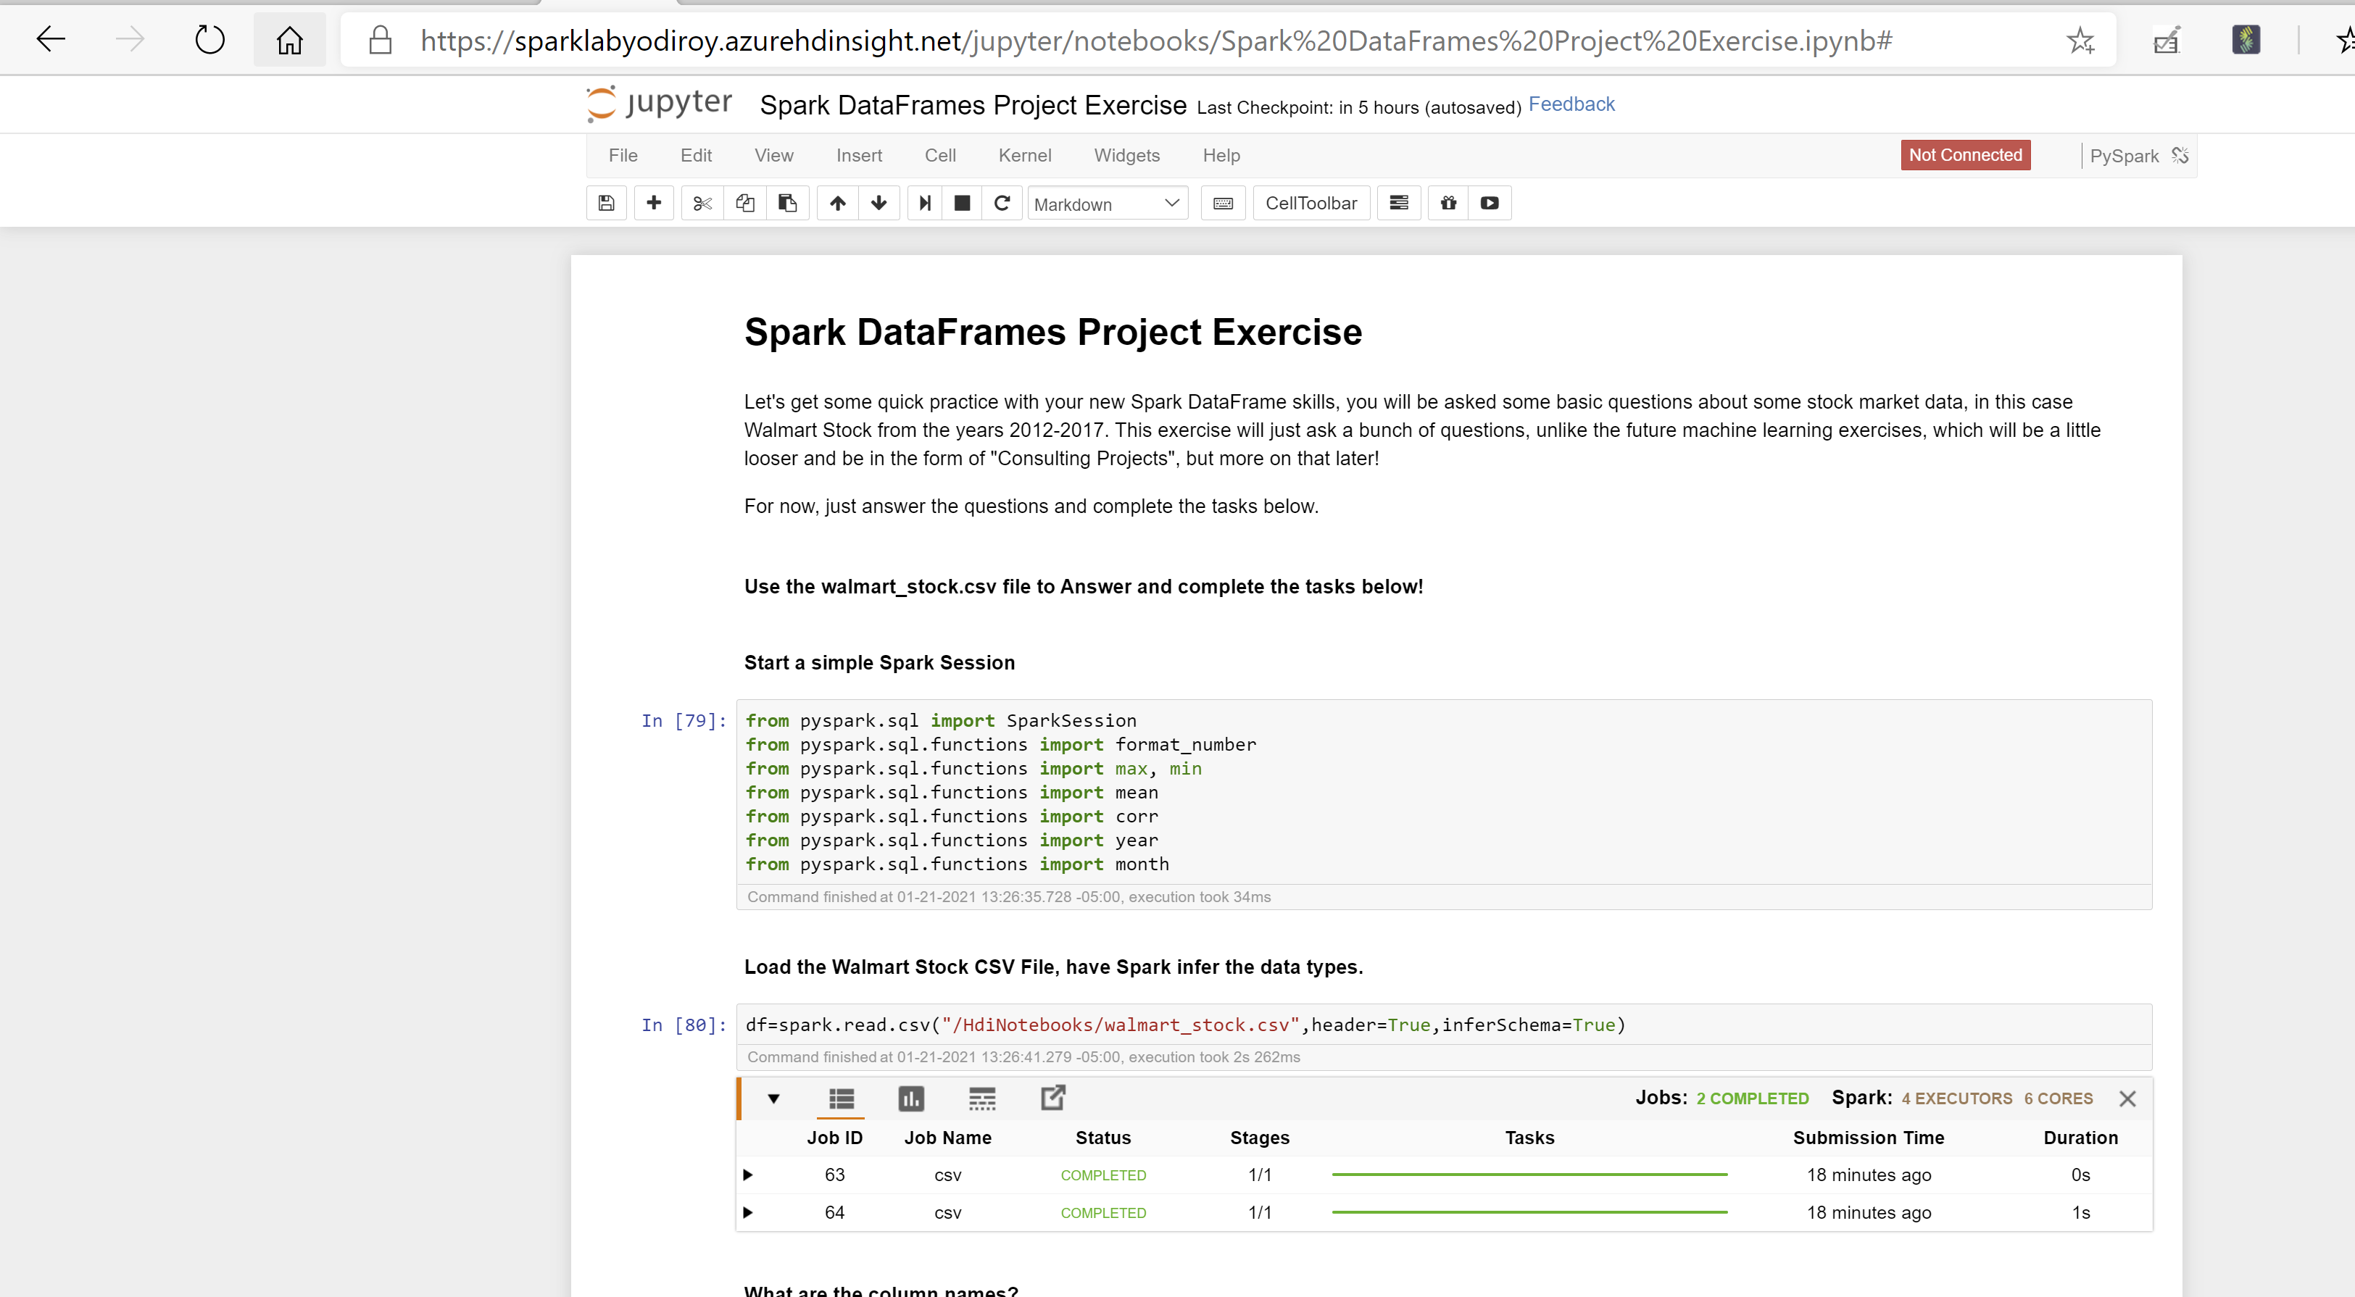

Deleted the cluster after completion of the above exercise.

